Thevenin’s theorem for AC circuit

Thevenin’s theorem for AC circuits states that any linear, two-terminal AC network (containing voltage/current sources, resistors, inductors, and capacitors) can be replaced by an equivalent circuit containing a single sinusoidal voltage source (Vth) in series with a single impedance (Zth). The equivalent impedance is calculated by deactivating independent sources (shorting voltage sources, opening current sources).

Key Steps for AC Thevenin Analysis:
- Remove Load Impedance: Disconnect the load (Z_{L}) from the terminals (A and B).

- Find V_{th}: Calculate the open-circuit voltage across terminals A and B, using techniques like phasor analysis, nodal analysis, or mesh analysis.

- Find Z_{th}: Determine the equivalent impedance looking back into the terminals with all independent sources deactivated (short-circuit voltage sources, open-circuit current sources).

- Construct Equivalent Circuit: Draw a single voltage source Vth in series with Z_{th} and reconnect the load Z_{L}
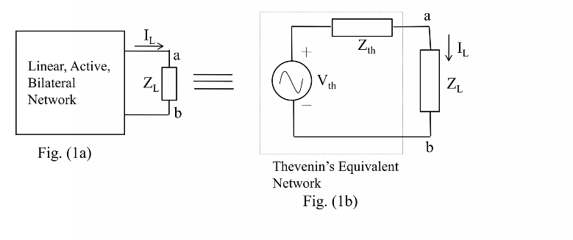

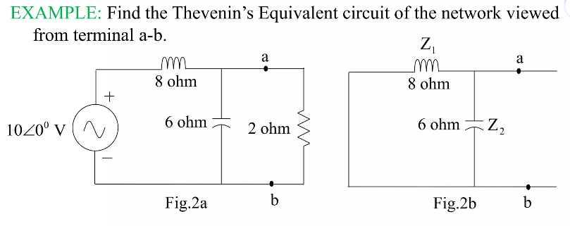
Norton's theorem
Norton's theorem for AC circuits states that any linear, two-terminal, bilateral network consisting of sources and impedances can be replaced by an equivalent circuit of a single constant current source I_{N} in parallel with a single impedance Z_{N}. It simplifies complex AC analysis by reducing the network to two components at a specific frequency, facilitating load variations.
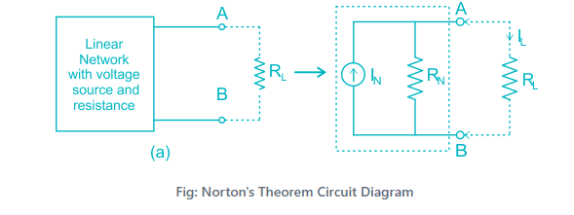

Steps to Apply Norton's Theorem in AC Circuits
- Identify Terminals: Remove the load impedance Z_{L} from the terminals (A and B) of the linear circuit.
- Calculate I_{N} (Norton Current): Find the short-circuit current flowing between terminals A and B, typically using mesh or nodal analysis with complex numbers.
- Calculate Z_{N} (Norton Impedance): Determine the equivalent impedance between terminals A and B with all independent sources set to zero (voltage sources shorted, current sources opened).
- Draw Equivalent Circuit: Connect the Norton current source IN in parallel with the Norton impedance Z_{N} and the load Z_{L} Calculate Load Current IL
- Use the current divider rule to find the current through the load:

Find the Norton’s equivalent of the following circuit.


